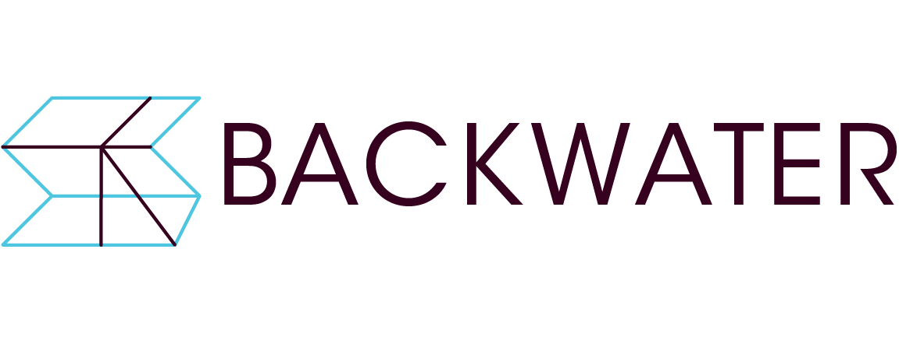

**Studio 12 Exhibition/Project Proposal**

**Submission Form**

1. **Contact name**:
2. **Contact email address**:
3. **Contact phone number**:
4. **Website/social media/blog links (if any)**:
5. **Artist Biography (max 200 words). For a group proposal artist biographies can be provided in an additional document:**
6. **Artist Statement (max 300 words). For a group proposal artist biographies can be provided in an additional document:**
7. **Title of proposed project**:
8. **Exhibition or Project Proposal (600 words maximum)**: Please state whether you are applying for an exhibition or project use of Studio 12. Please include details of any public events which will accompany the project.

**List of supporting images / videos including title, date, medium, dimensions (if relevant and/or known).** Supporting images / video: Images (max 10 images) to be of adequate resolution (min 1MB – max 2MB). Videos where applicable can be included as video links (e.g. Vimeo/Youtube) or sent via online file transfer (Wetransfer/Dropbox):

1. **Budget:** Please provide details of the production costs involved in delivering the project. We will provide an artist’s fee (amount tbc on receipt of funding). Travel and accommodation costs will also be provided to artists travelling from outside of Cork. Please specify if you will have travel and accommodation costs. If you have a cost for a curator, please include it here. You may provide this in a separate excel spreadsheet with your support material if you prefer.

|  |  |
| --- | --- |
| **Budget** |  |
| *add any additional projected expense and disregard ones that do not apply to your proposal | **Amount** |
|  |  |
| Artwork/Project Production Fee |  |
| Curator Fee |  |
| Travel and Accommodation Costs for curator and/or artist |  |
| Engagement Event - materials |  |
| Framing |  |
| Equipment |  |
|  |  |
|  |  |
|  |  |
|  |  |
| **Total** | 0 |

**List of supporting documents / cv / portfolio material**:

1. **Please outline how your proposed exhibition is suitable for the space. (max. 100 words):**
2. **List of supporting images / videos including title, date, medium, dimensions (if relevant and/or known).** Supporting images / video: Images (max 10 images) to be of adequate resolution (min 1MB – max 2MB). Videos where applicable can be included as video links (e.g. Vimeo/Youtube) or sent via online file transfer (Wetransfer/Dropbox):

It is recommended that each submission (excluding videos) be submitted as a single PDF document (max 20MB).

Please submit proposals by email or online file transfer (dropbox or wetranfer) to **elaine@backwaterartists.ie.**

If you have any further queries please contact:

1. **List of documents (CV, portfolio, letters of support)**

It is recommended that each submission (excluding videos) be submitted as a single PDF document (max 20MB).

Please submit proposals by email or online file transfer to **elaine@backwaterartists.ie** by **Friday 6th October at 5.00pm.**

Please note your information will be stored in compliance with GDPR requirements and will only be used to assess your eligibility for the available Exhibition/Project Residency slots at Backwater Artists Group in 2026. By submitting your application you are authorising Backwater Artists Group to contact you about the open call.

If you have any further queries please contact:



Backwater Artists Group, Wandesford Quay, Cork. Tel: (021) 4961002

Email: [elize@backwaterartists.ie](mailto:elaine@backwaterartists.ie). Web: http://www.backwaterartists.ie