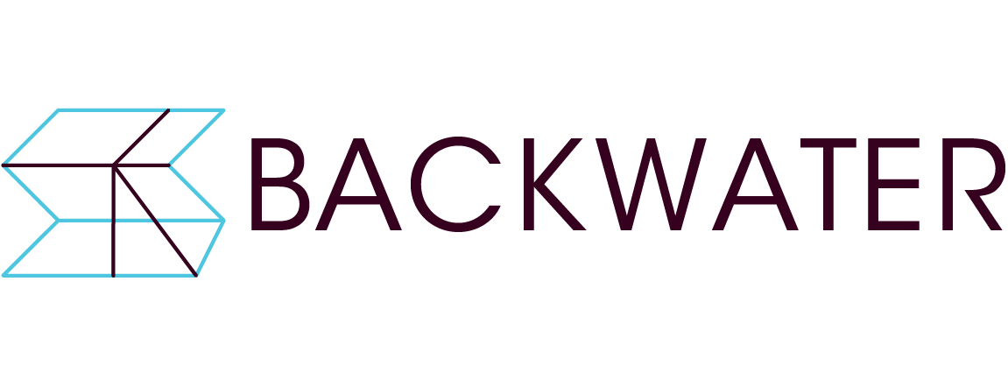
Darkroom & Digital Production Facility
Submission Form

Contact name:

Contact email address:

Contact phone number:

Website/social media/blog links (if any):

Artist Biography (max 120 words).

Artist Statement (max 300 words). Optional.

Outline how you propose to use the facilities (max 100 words).

List of supporting images / videos including title, date, medium, dimensions (if relevant and/or known). Supporting images / video: Images (max 10 images) to be of adequate resolution (min 1MB – max 2MB). Videos where applicable can be included as video links (e.g. Vimeo/Youtube) or sent via online file transfer (Wetransfer/Dropbox):

List of supporting documents / cv / portfolio material:

It is recommended that each submission (excluding videos) be submitted as a single PDF document (max 20MB).
Please submit proposals by email or online file transfer (dropbox or wetransfer) to michelle@backwaterartists.ie by 11 April 2022. Applicants will be notified by 15 April and interviews for shortlisted applicants held on 25 April. Successful applicants will be notified by 27th April and darkroom usage will commence 3rd May 2022.

If you have any further queries please contact:

Backwater Artists Group
Wandesford Quay, Cork
Tel: (021) 4961002
Email: michelle@backwaterartists.ie
Web: http://www.backwaterartists.ie

